**A CRM APPLICATION FOR SCHOOLS/COLLEGES**

1. **INTRODUCTION**
   1. **Overview**

**A school management CRM ( customer relationship management ) is a software tool designed to help schools and educational manage their interactions with students ,parents ,teachers, and other stakeholders. With a school management CRM ,you can :**

**Keep track of student and parent contact information , including phone numbers ,email addresses, and physical addresses**

**Track and analyze student performance and progress**

**Overall, a school management CRM helps to streamline and automate many of the administrative tasks associated with running a school, making it easier for educators to focus more on their primary goal of providing high-quality education to their students .**

* 1. **Purpose**

**A CRM application for school / college project is used for**

* **It help a relation to keep parents.**
* **It helps to how to understand what it needs to do to get more informations.**
* **Reduce costs by managing costly complaints and finding out what services are useless for parents.**
* **Help a student our its is working and ultimately, increases a relationship.**
* **It is very use full for school management and parent relationships.**

**Using the CRM application for school we can get the full details of the individuals of every students it will help teacher to more focus on there primary goal . It will be helpful for parents to connect to the students activity and hoe to performance .It will provide the school details and it can be accessed from anywhere. It will consume less time and it will be helpful in managing time . It will give us dashboard and the the reports of the schools, students and parent .**

1. **Problem Definition & Design Thinking** 
   1. **Empathy Map**

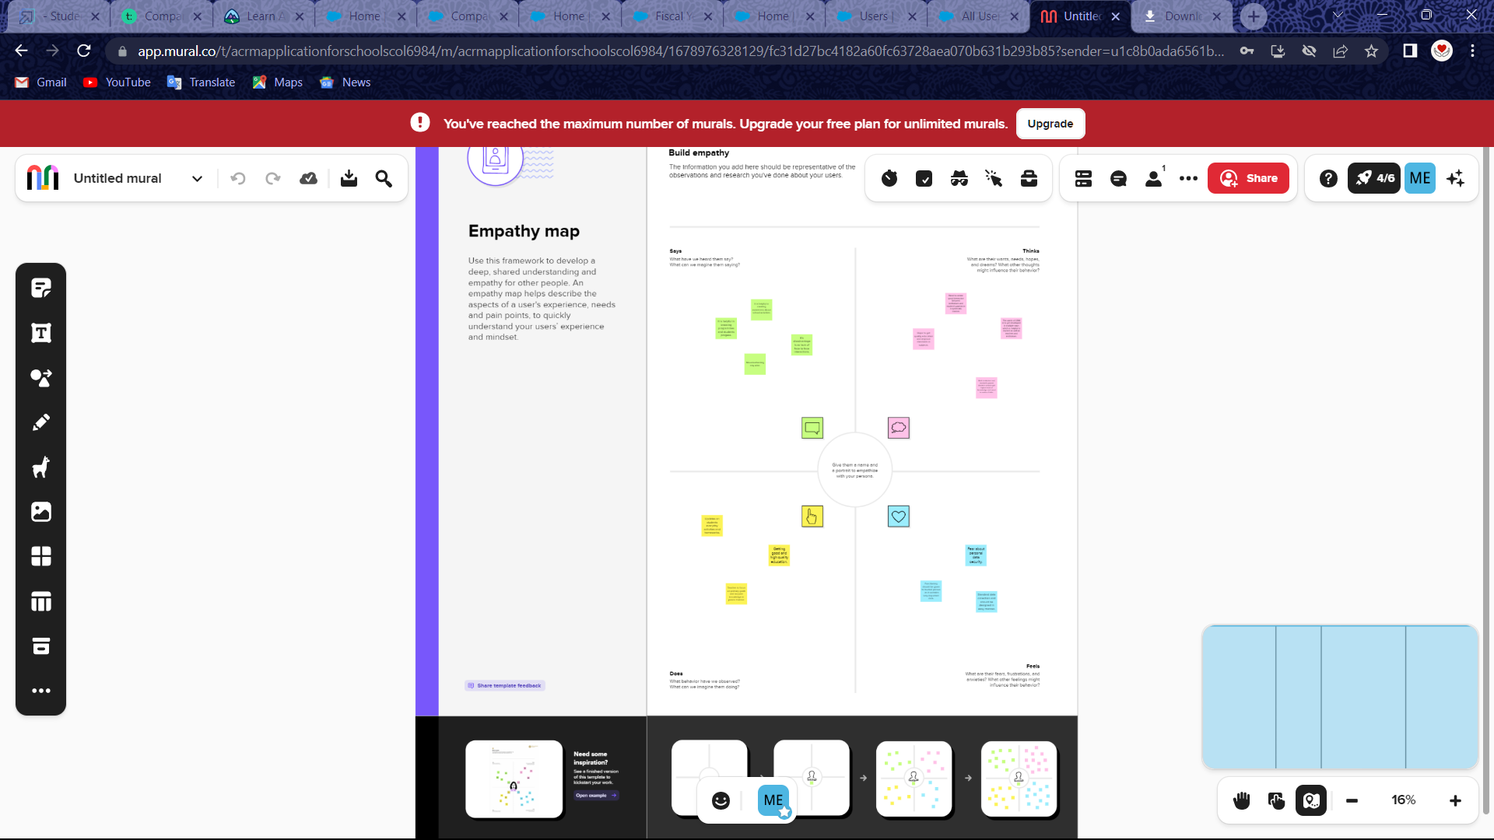

* 1. **Ideation & Brainstorming Map**

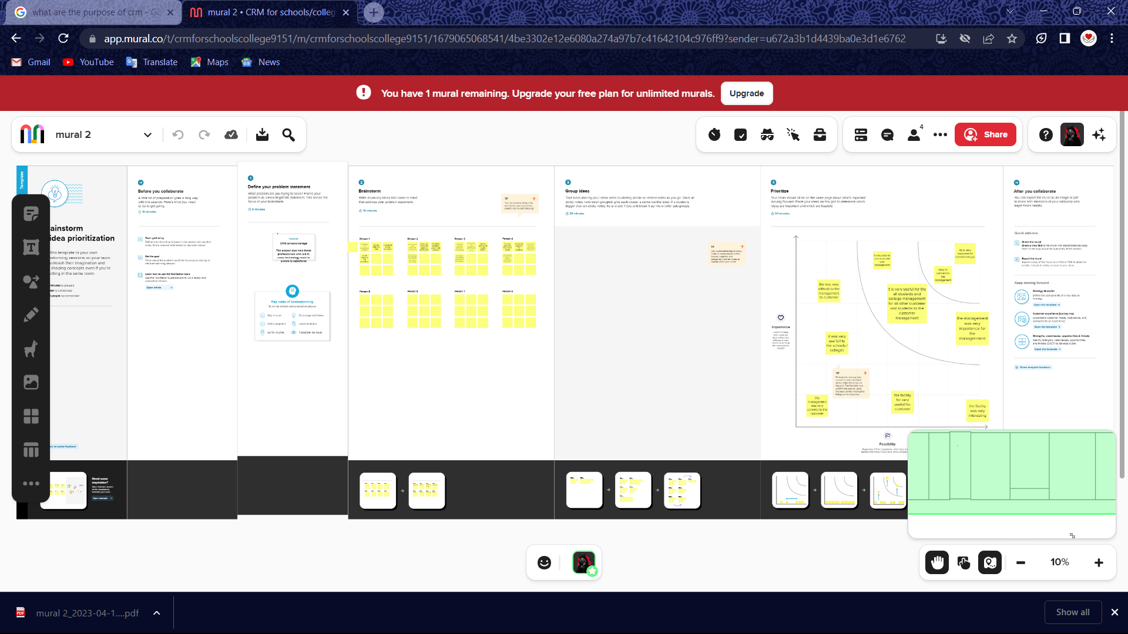

1. **RESULT**

**3.1 Data Model:**

|  |  |
| --- | --- |
| **Object name** | **Fields in the Object** |
| **School** | |  |  |  | | --- | --- | --- | | **Field Label** | **Data Type** | | | **Address** | **Text Area** | | | **District** | **Text Area** | | | **School** | **Text Area** | | | **Phone Number** | **Phone** | | | **Number of Students** | | **Roll-up Summary** | | **Highest Marks** | | **Roll-up Summary** | |
| **Student** | |  |  | | --- | --- | | **Field Label** | **Data Type** | | **Phone Number** | **Phone** | | **School** | **Master- Detail Relationship** | | **Results** | **Picklist** | | **Class** | **Number** | | | **Marks** | **Number** | | |
| **Parent** | |  |  | | --- | --- | | **Field Label** | **Data Type** | | **Parent Address** | **Text Area** | | **Parent Number** | **Phone** | |

**3.2 Activity &Screenshot**

**Activity 1:**

**Creation of school object**

**Creation of Objects for School Management:**

**The school management need to create 3 objects schools, parents, And students.** 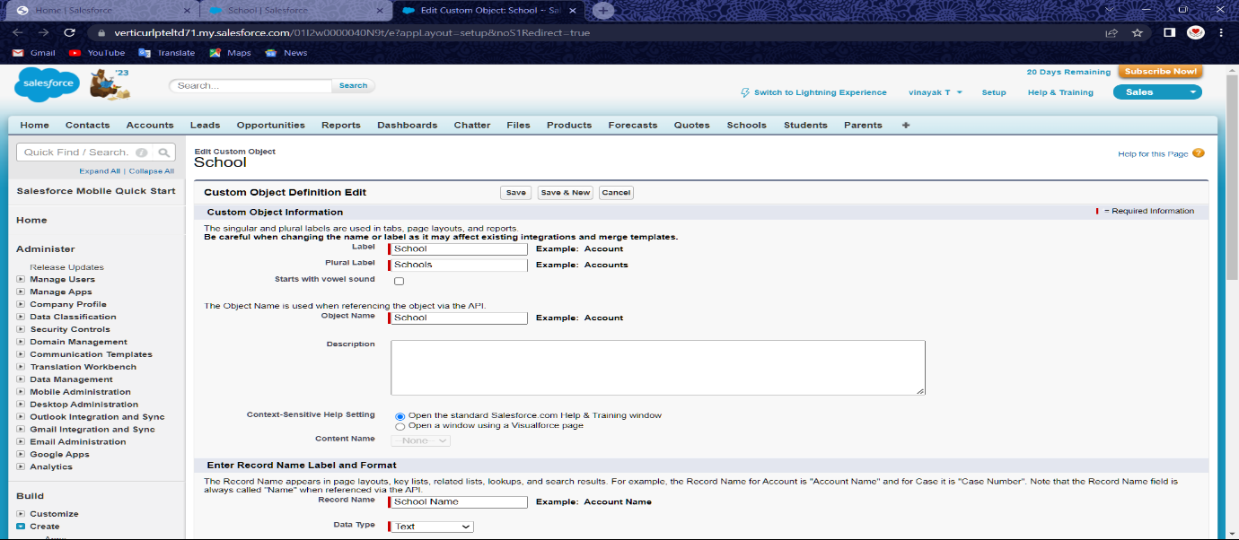

**Click to the gear icon. The next step click on the object manager. Then click to the object manager dropdown sympol . Then select to the custom object. Then custom object tab is open. Then fill up the label name in School and plural name schools. Then Click object name to a school . Then click option features click allow reports. Then search status click allow search. Then click to the Save and then under Custom Object Tabs, click New and For Object, select School and For Tab Style, select any icon. Leave all defaults as is. Click Next, Next, and Save.**

**Then finish the all the steps, then show the school objects box is shown in the schools details.**

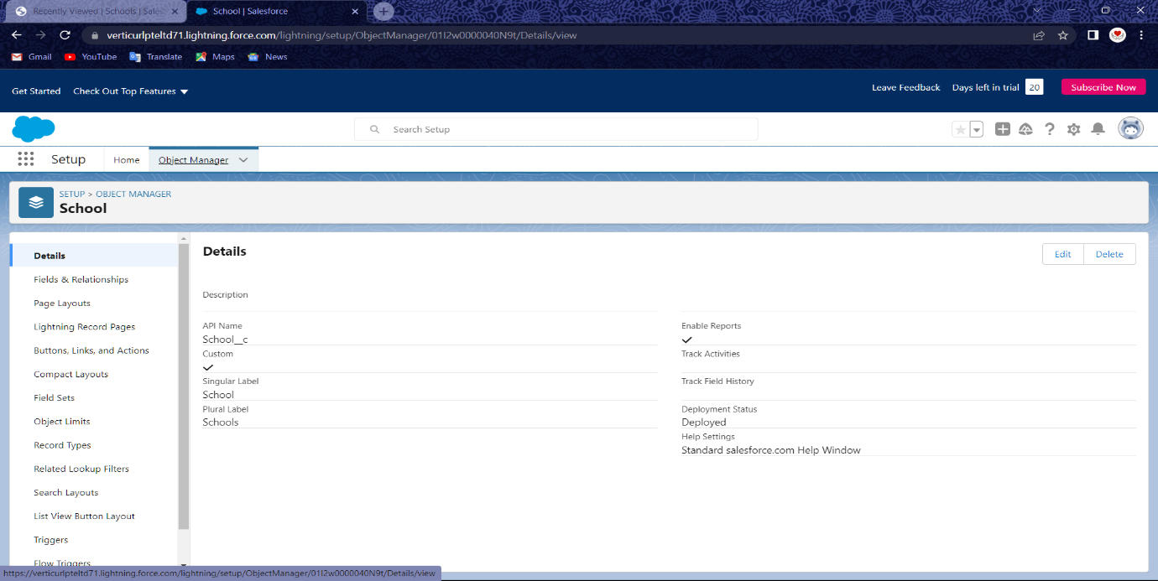

**Activity: 2**

**Create student Objects:**

**Click to the gear icon. The next step click on the object manager. Then click to the object manager dropdown sympol . Then select to the custom object. Then custom object tab is open. Then fill up the label name in Student and plural name students. Then Click object name to a student. Then click option features click allow reports. Then search status click allow search. Then click to the Save and then under Custom Object Tabs, click New and For Object, select Student and For Tab Style, select any icon. Leave all defaults as is. Click Next, Next, and Save.**

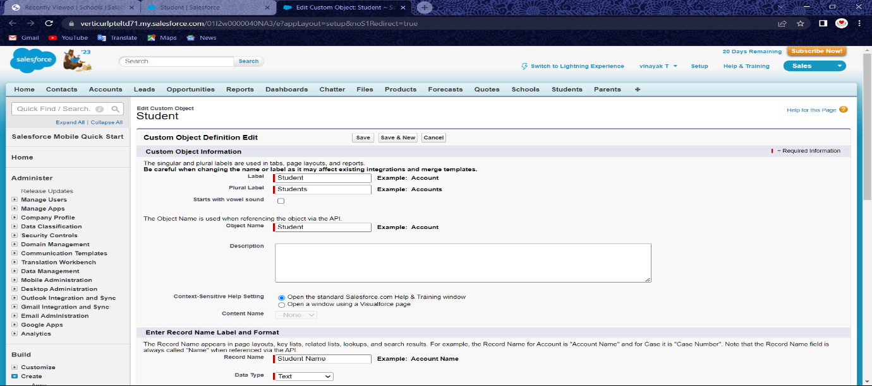

**The custom objects created then open the students details box menu.**

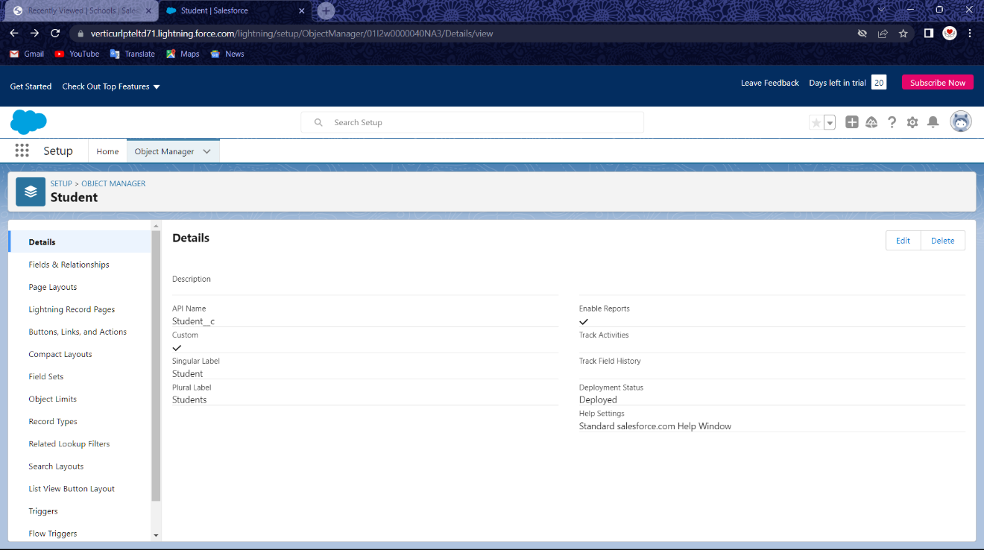

**Activity :3**

**Create Parent objects:**

**Click to the gear icon. The next step click on the object manager. Then click to the object manager dropdown sympol . Then select to the custom object. Then custom object tab is open. Then fill up the label name in Parent and plural name parents. Then Click object name to a parent. Then click option features click allow reports. Then search status click allow search. Then click to the Save and then under Custom Object Tabs, click New and For Object, select parent and For Tab Style, select any icon. Leave all defaults as is. Click Next, Next, and Save.**

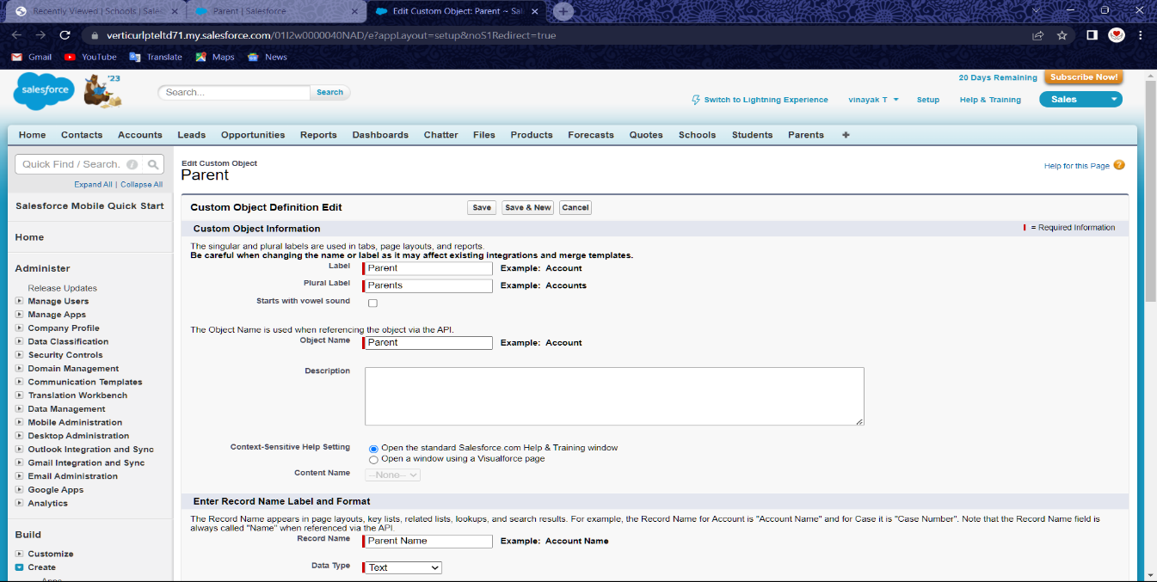

**The custom objects created then open the Parents details box menu.**

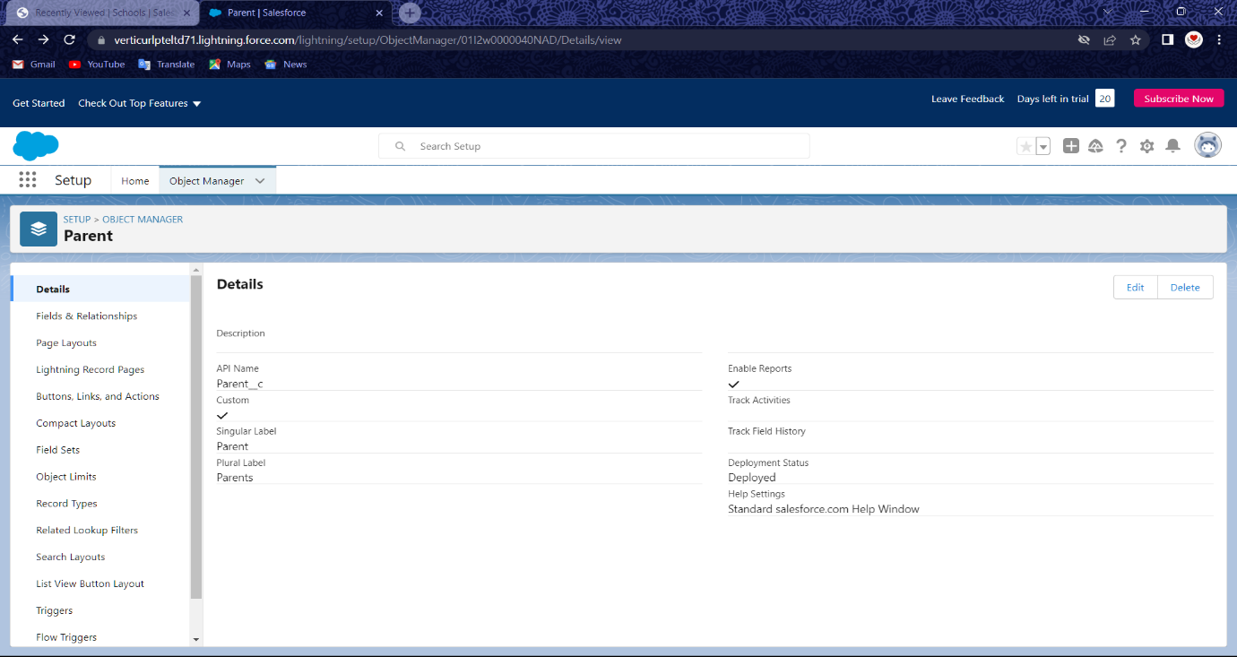

**Milestone- Lighting App**

**Activity: Create the School Management app**

**The click gear icon. Then click App manager in the quick find and then select app manager.**

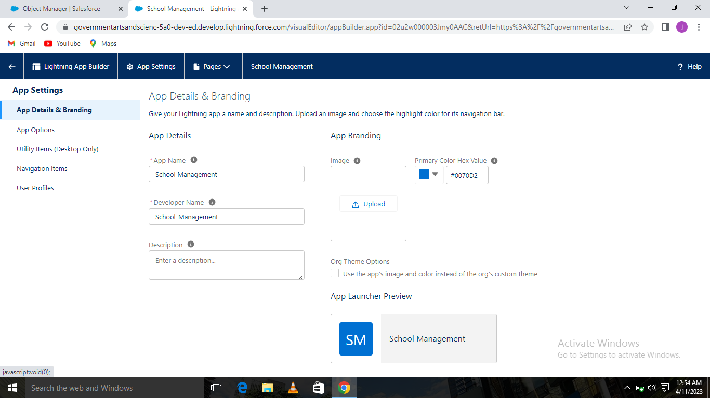

**Then select Under App Options, leave the All the default selections and click Next.**

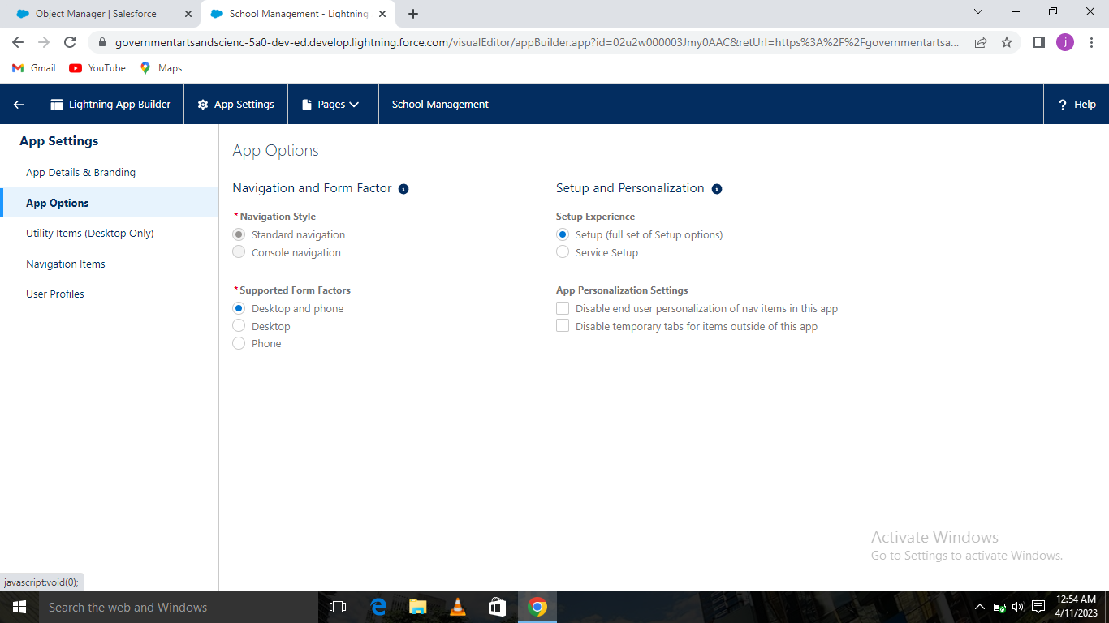

**The click the Under Utility Items, leave and click Next.**

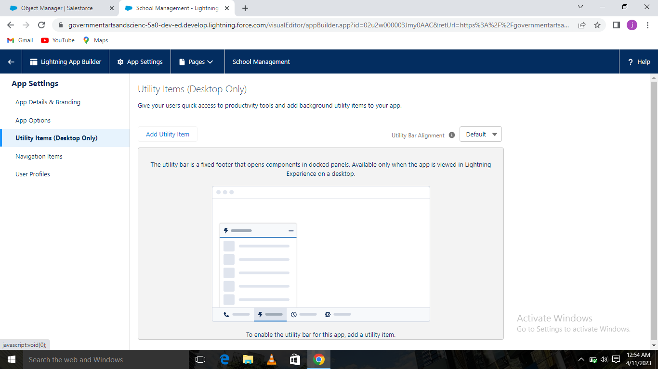

**Then click Available Items, select Schools, Students, Parents, Reports, and Dashboards and then move them to Selected Items. Click Next.**

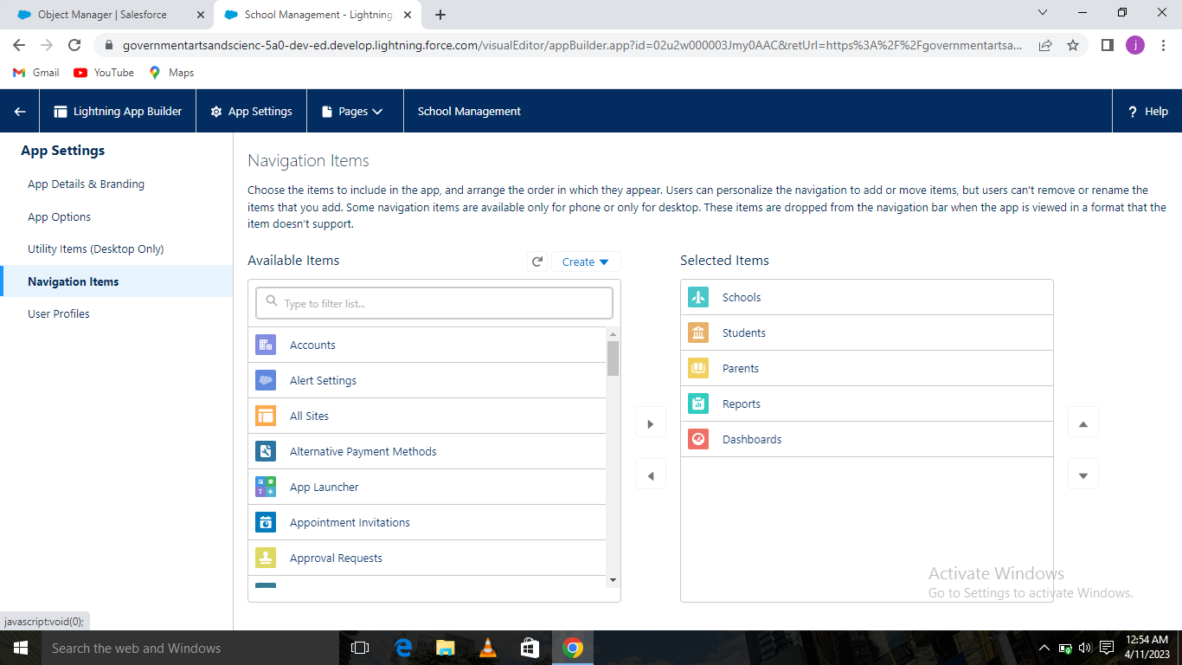

**Available Profiles, select System Administrator and move it to Selected Profiles.**

**Click Save & Finish. To verify your changes, click the App Launcher, type School Management and select the School Management app. The School Management has been prepared.**

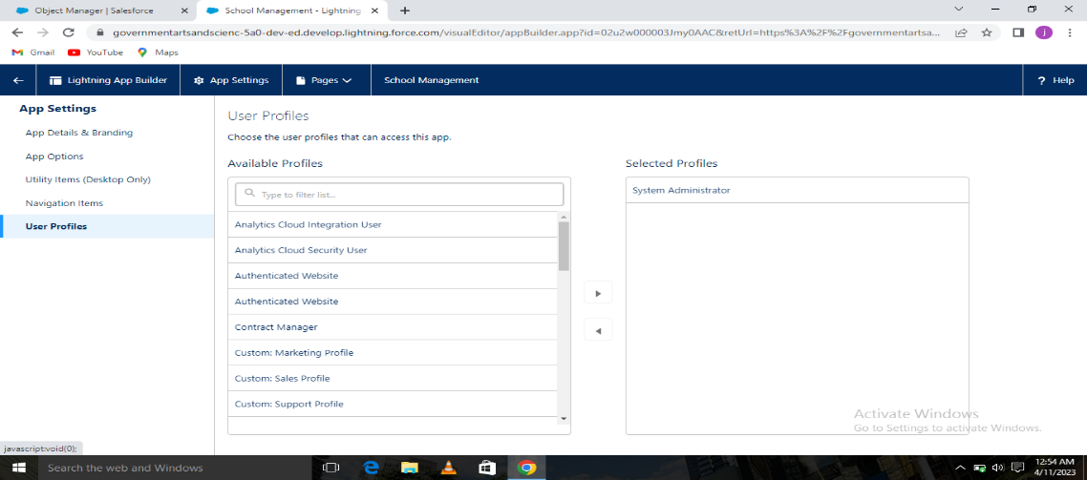

**Milestone -Fields and Relationship**

**Activity-1: Creation of fields for the School objects:**

**Click on the school object. Select Fields & Relationships from the left navigation, and click New. Select the Text Area as the Data Type, click Next .then Field Label, enter Address .Click Next, Next, then Save & New.**

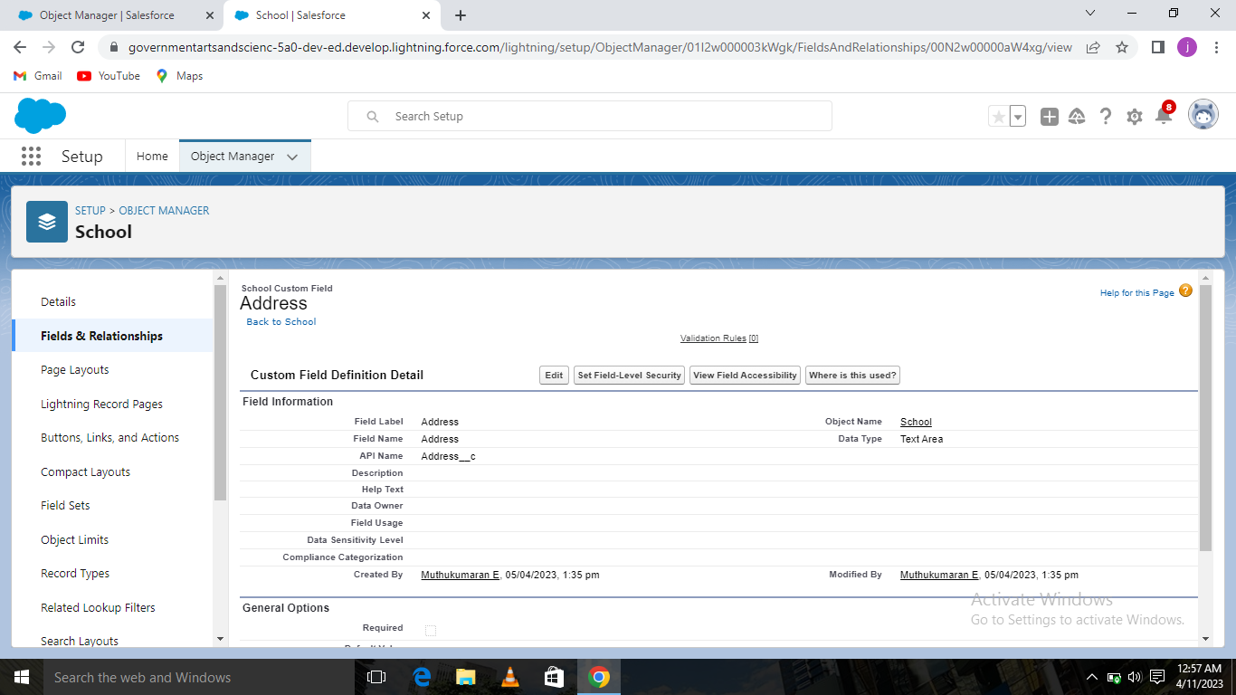

**Then create one or more text areas with District, State and School websites as the field labels as we have done above.**

**Activity-2: Creation of fields for the Student objects:**

**Click on the studentl object. Select Fields & Relationships from the left navigation, and click New. Select the Text Area as the Data Type, click Next .then Field Label, enter Address .Click Next, Next, then Save & New.**

**Activity-3: Creation of fields for the Parent objects:**

**Click on the parent object. Select Fields & Relationships from the left navigation, and click New. Select the Text Area as the Data Type, click Next .then Field Label, enter Address .Click Next, Next, then Save & New.**

**Milestone- Profile**

**Activity: Creation on profile**

**Setup to the enter Profiles in then click Quick Find box, and select the Profile. From the list of profiles, then find to the Standard User. Click Clone. For Profile Name, enter School profile. Then Click Save.**

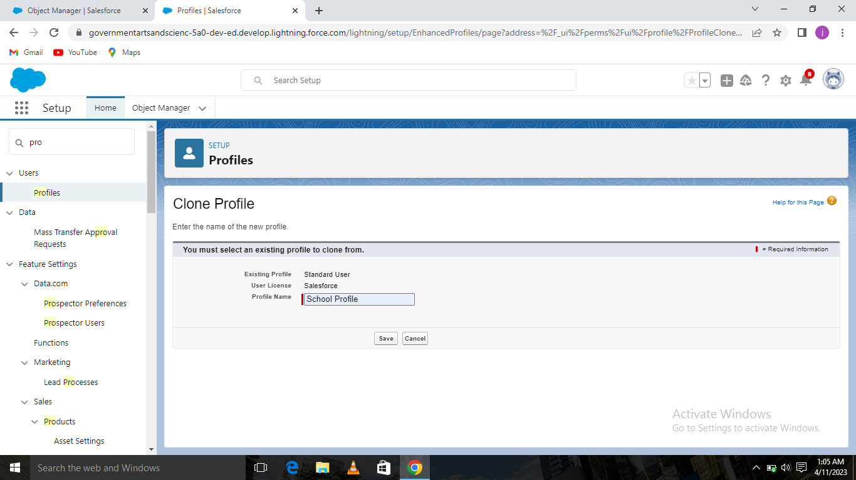

**Then click to the School profile page, then click Edit .Scroll down to the Custom Object Permissions and Give to view all access permissions to the parent profile.**

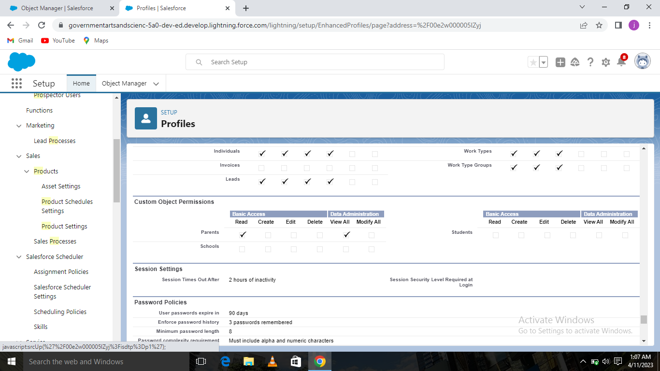

**Milestone- Users**

**Activity: Creating a Users:**

**From Setup, in the Quick Find box, enter Users, and then select Users . Click New User.**

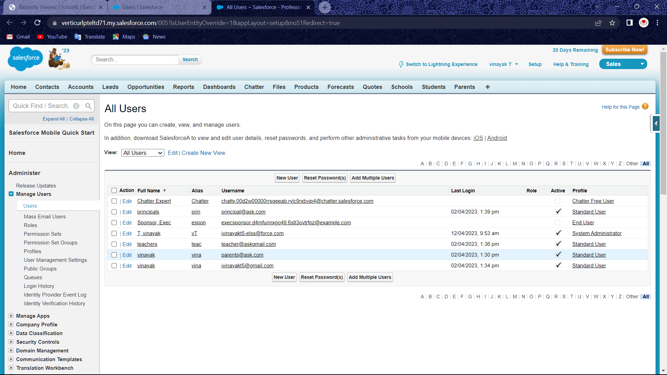

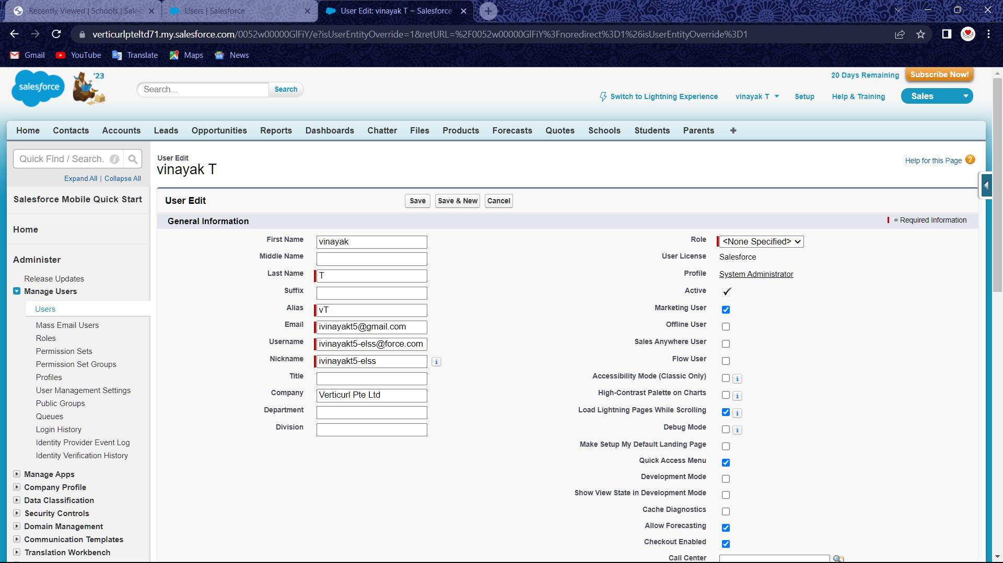

**Then follow the above steps and create users Teachers.**

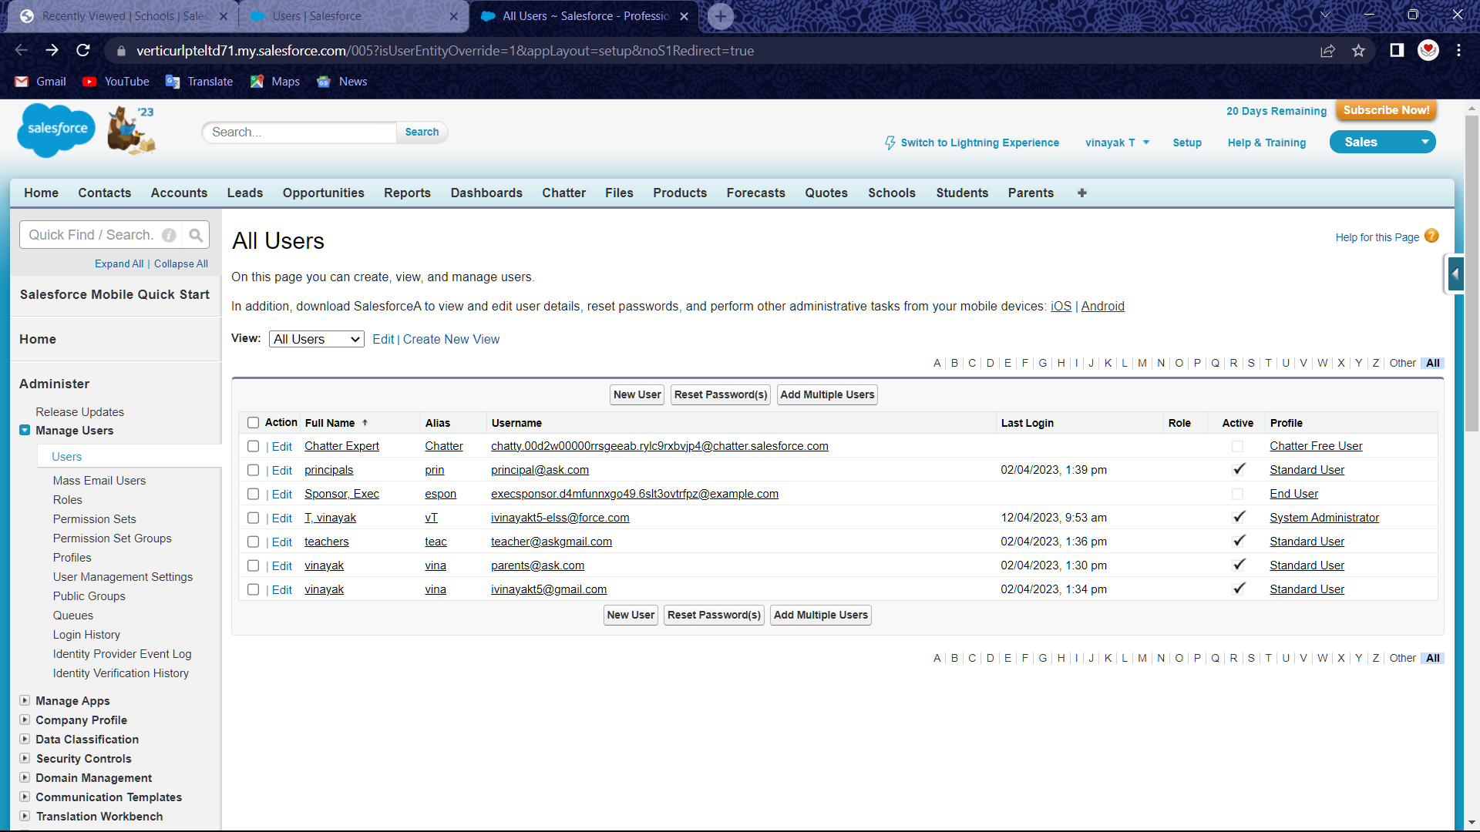

**Then follow the above steps and create users Teachers.**

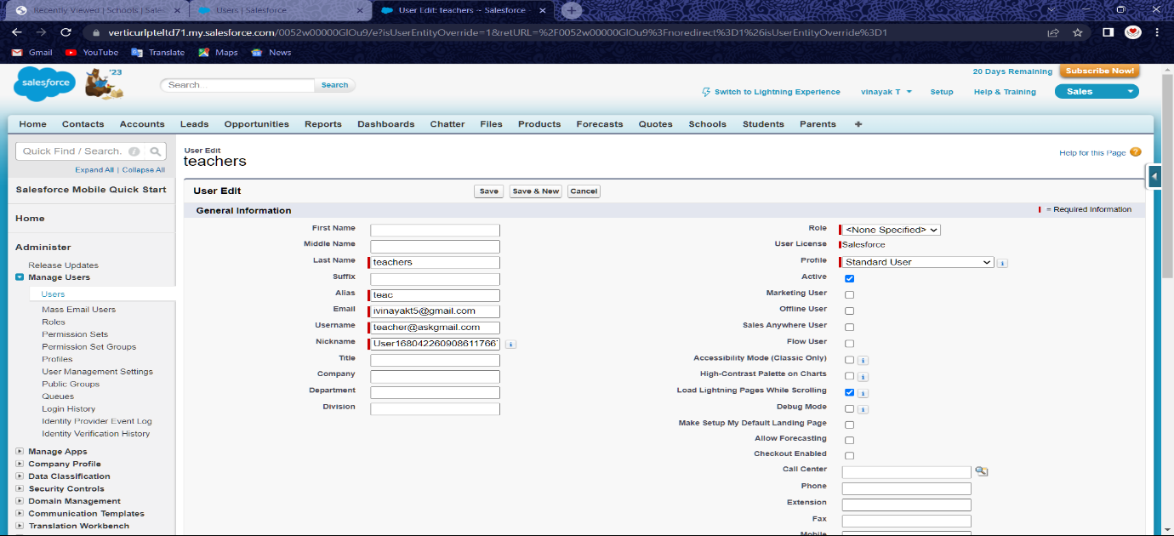

**Then follow the above steps and create users Principal**

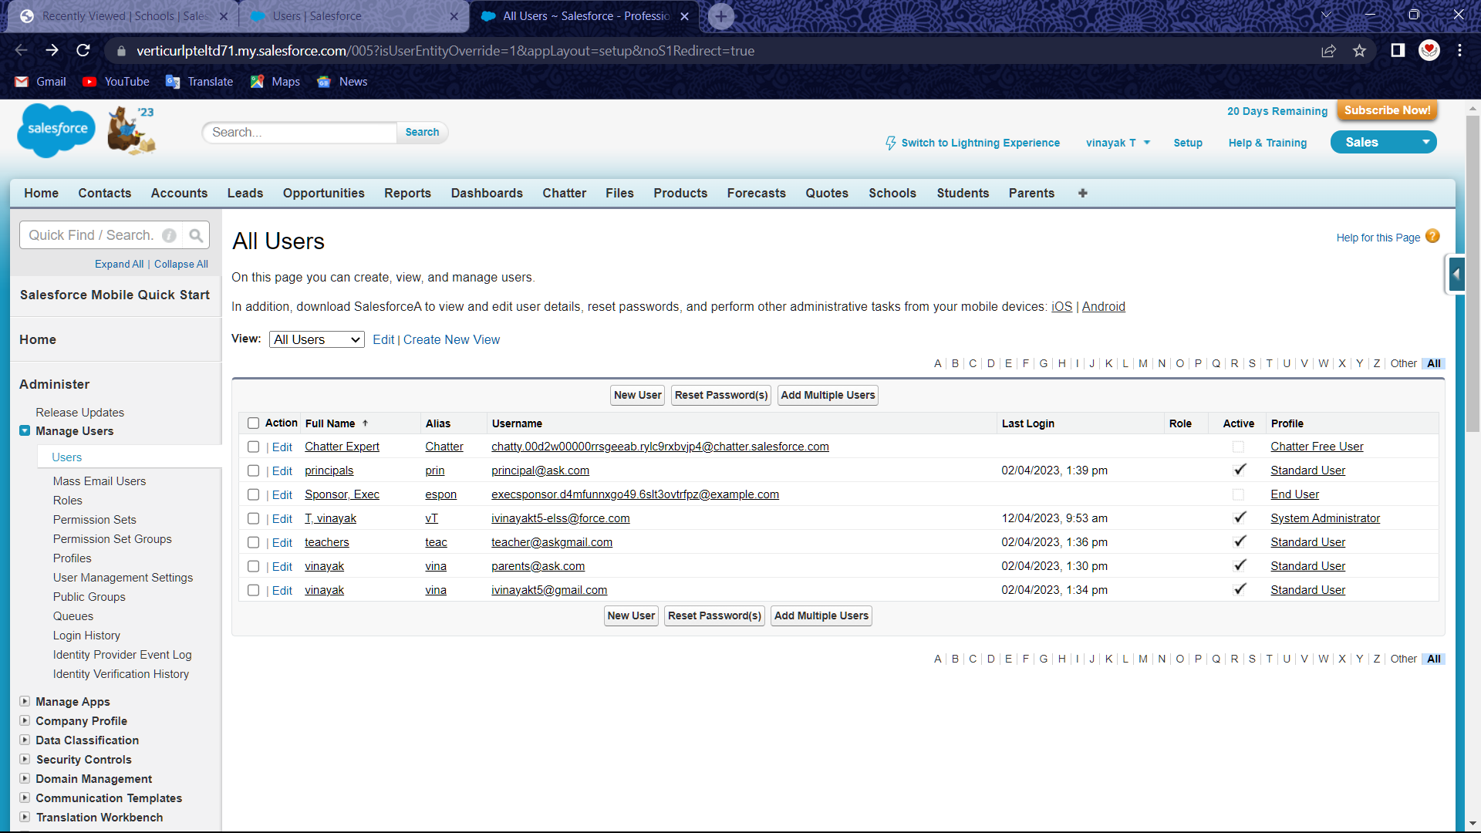

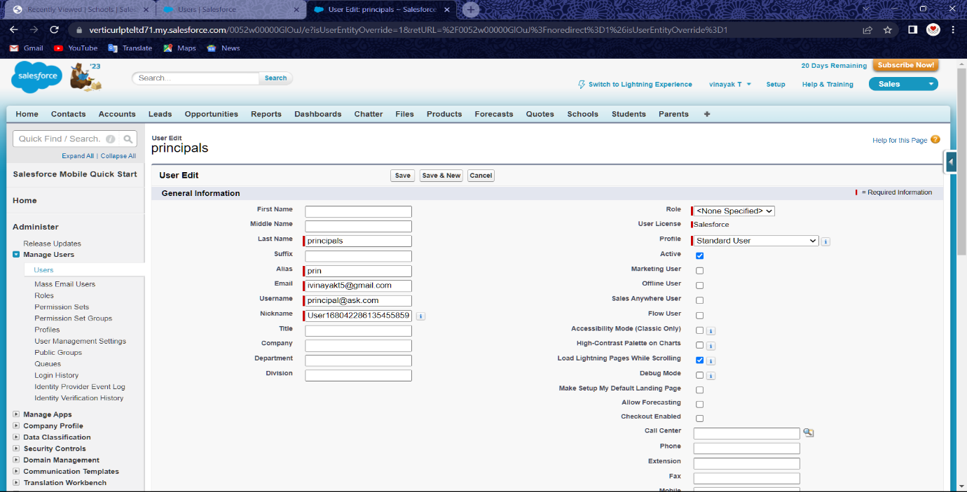

**Milestone-Permission sets**

**Activity-1: Permission sets 1**

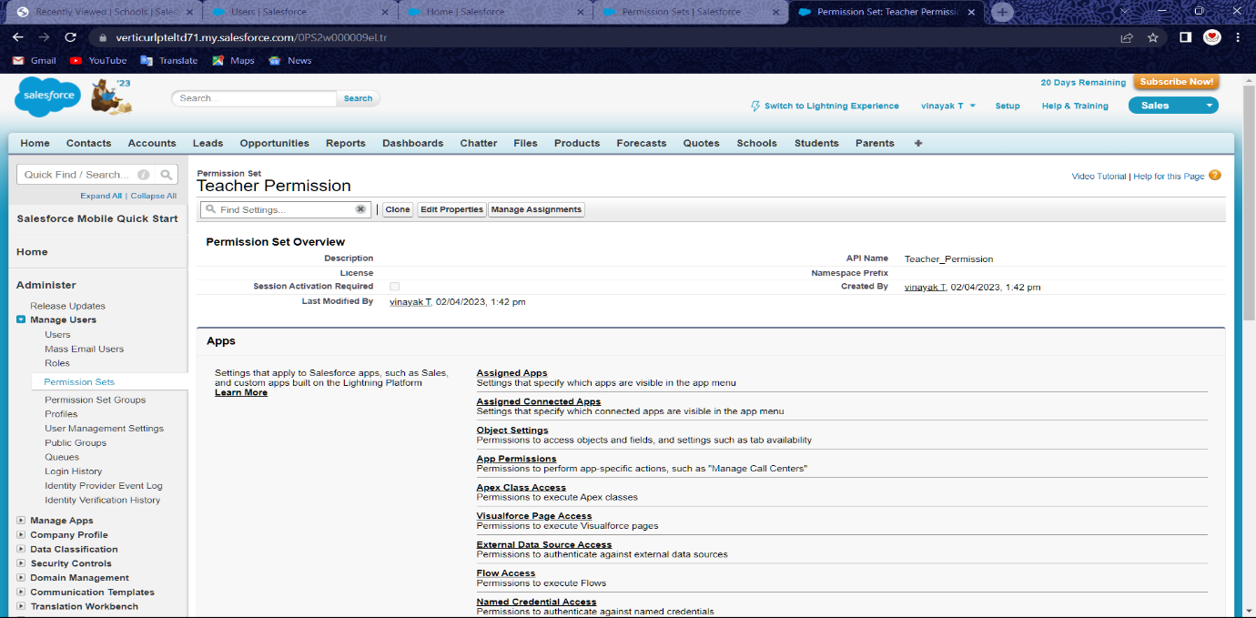

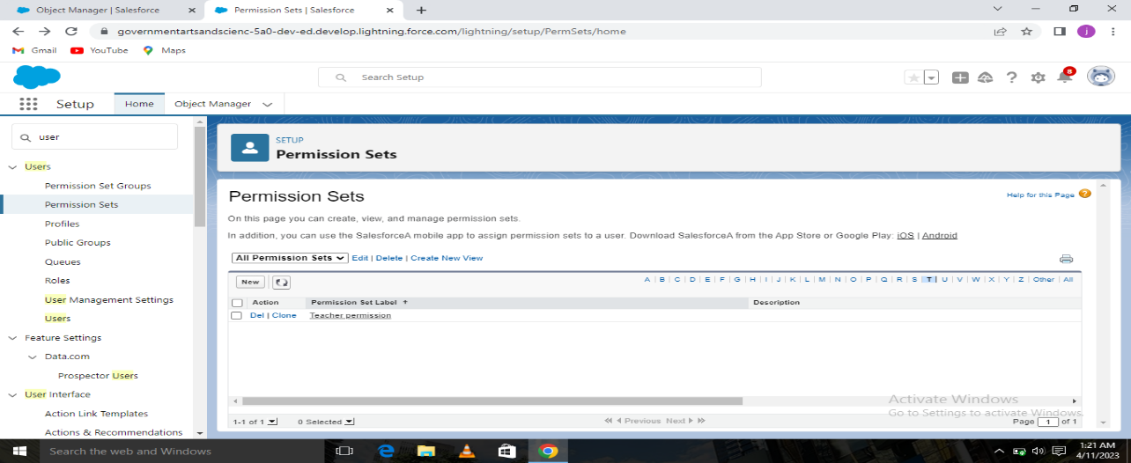

**Activity-2: Permission sets 2**

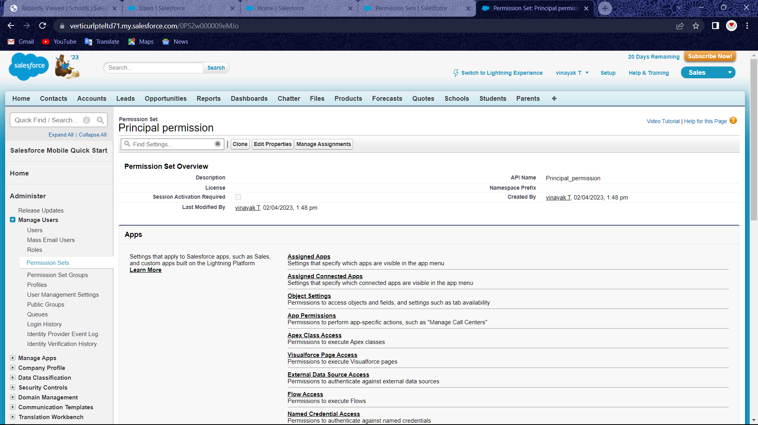

**Milestone-Reports**

**Activity- Reports :**

**From the Reports tab, click New Report. Select the report type as School with students and parents for the report, and click Create. Customize your report, then save or run it.**

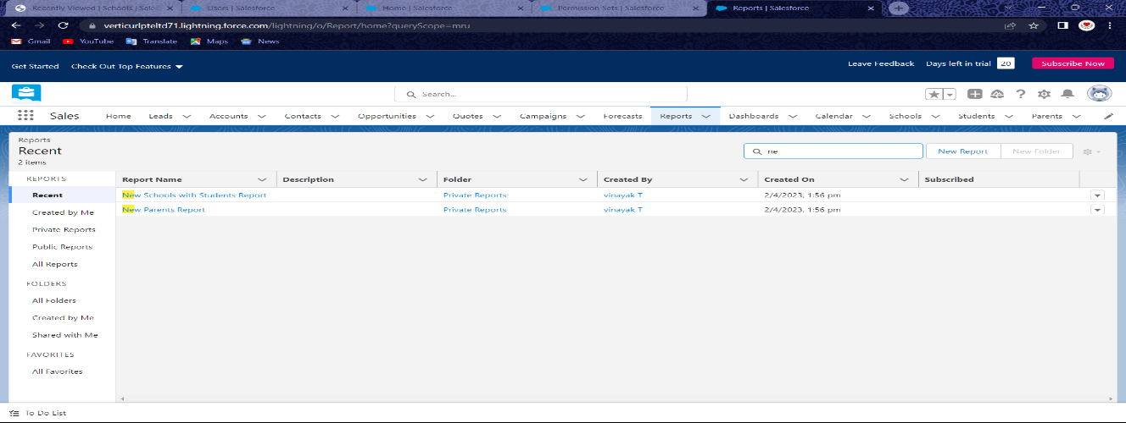

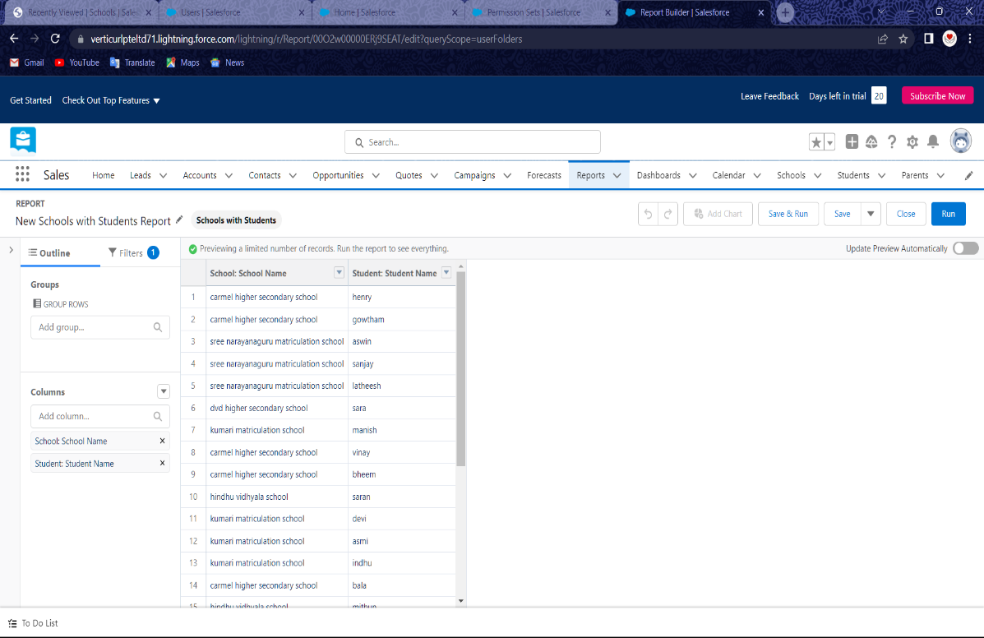

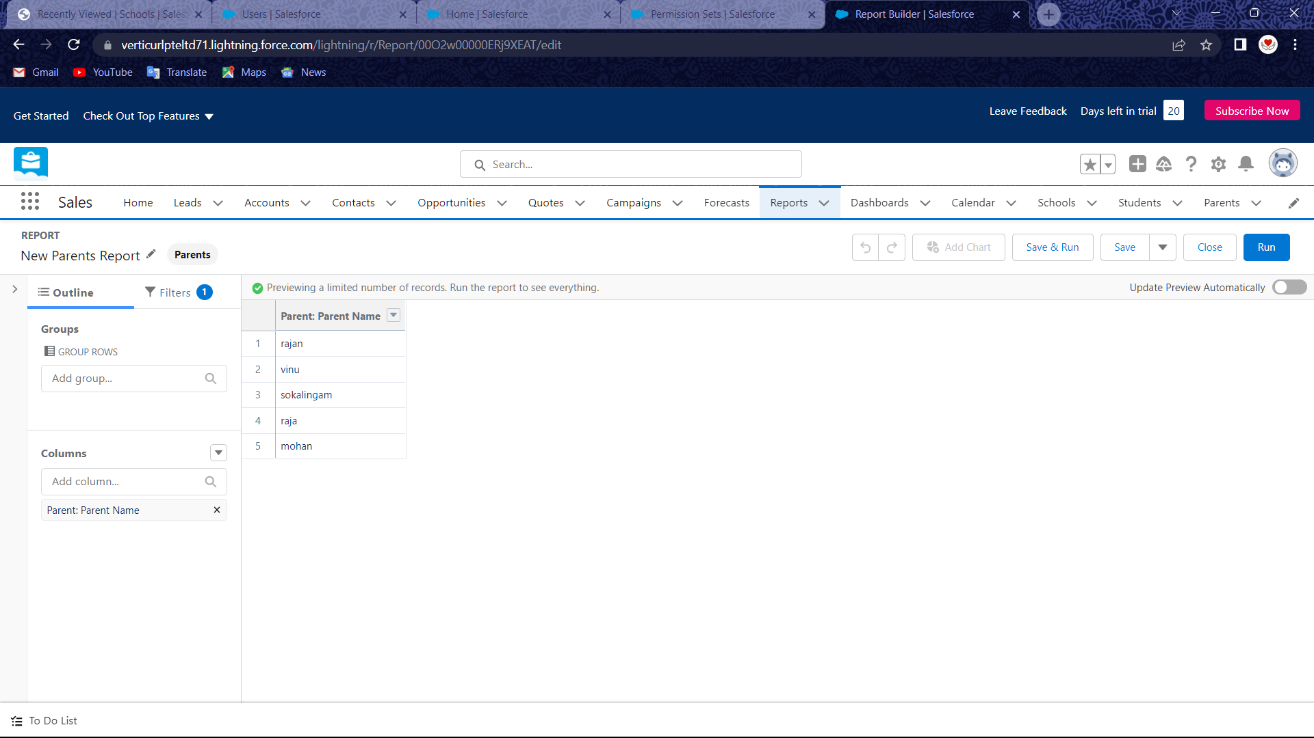

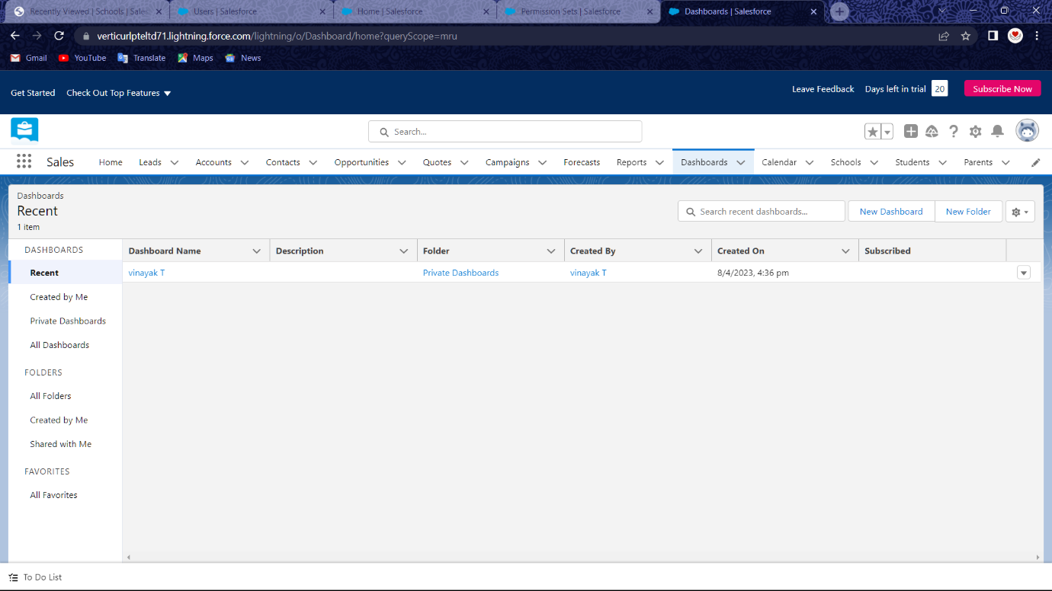

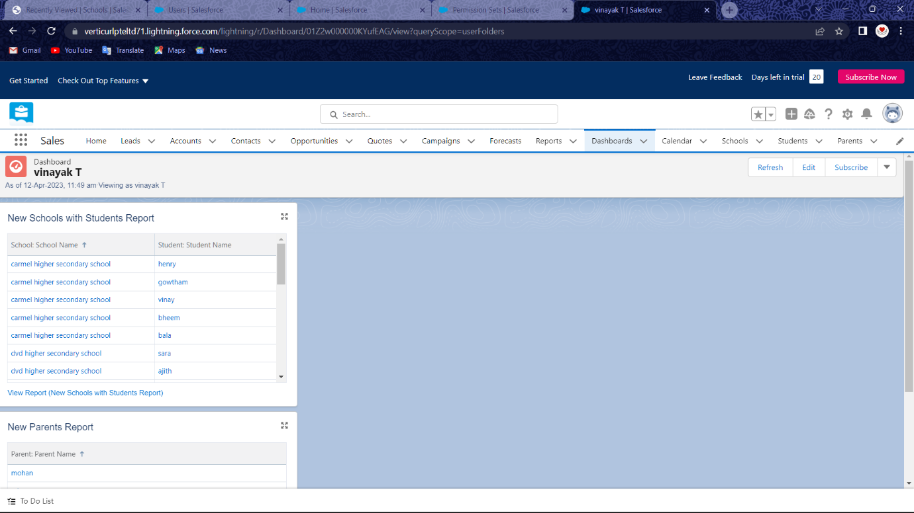

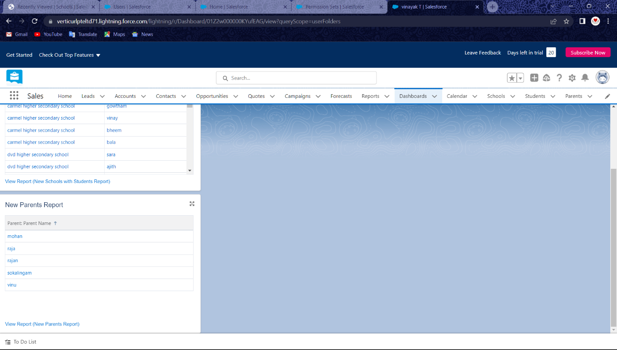

1. **Trailhead profile URL**

**Team Lead –** [**https://trailblazer.me/id/vinayak38**](https://trailblazer.me/id/vinayak38) **( Vinayak T )**

**Team member 1-** [**https://trailblazer.me/id/ii2tl**](https://trailblazer.me/id/ii2tl)

**Team member 2-** [**https://trailblazer.me/id/balat20**](https://trailblazer.me/id/balat20)

**Team member 3-** [**https://trailblazer.me/id/henkb2**](https://trailblazer.me/id/henkb2)

1. **Advantages & Disadvantages**

**Advantages:**

1. **It is very useful to relation to school management and parent relationship.**
2. **All the students data are store in the portal**
3. **Improve to message with the parents**
4. **It is trust application**
5. **Simplified collaboration**

**Disadvantages:**

1. **Security issuses**
2. **Third party application**
3. **The datas are easily track to the spy**
4. **Time consuming process**
5. **The apps was very risk**
6. **Applications**
7. **Schools**
8. **Lab**
9. **Industrial areas**
10. **Hospitals**
11. **Education institution**
12. **Colleges**

**7 Conclusion**

**This application was very informative .This application is giving us all the detailed account of schools ,students and parents . This application helps to the betterment of the individuals performance in academics**

**8 Future Scope**

**Customers will become a company’s best sales reps through superior products and services as well as customer-oriented messaging. The future of CRM is more than just the future of Customer Relationship Management Software. It is really the Future of Business.**